Synamedia MEG setup – **HSN**

HSN1 HD MP4 TSoip Out

**Task-** Configuring Synamedia MEG IRDs

**Condition-** Service Routing HSN1 HD MP4 - TSoip OUT

**Standard-** How to configure a Synamedia MEG IRD for Service Routing

**Action Items:**

* Service Routing HD MP4
  + Begin by **Browsing to IP** of MEG IRD (Default ip - 192.168.2.20)
    - **Enter UN & PW** *(see figure 1) (UN: Admin ; PW: Password)*

*Figure 1 - Login*

* Click on **Add New Channel** *(see figure 2)*

Figure 2 – Add Channel

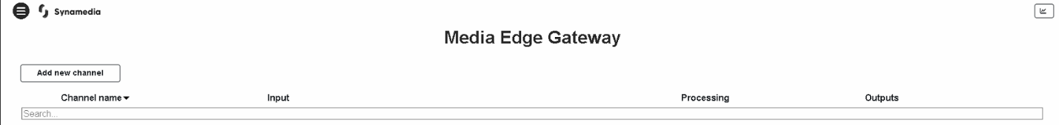

* + Choose which option you would like to do
    - Select **Service Routing** for TSoip setup *(see figure 3)*

Figure 3 – Service Routing

* + Service Routing – TSoip
    - Enter a **Channel Name (HSN1 HD MP4 TSoip Out)**
    - Select **Use Existing Input**
    - **Input Selection - DVB-S2:DVBS2 1 (4.08GHz)**
  + Select which **Service ID** you would like to Service Route by choosing the service in the **Dropdown Menu - (20) for HSN1 HD** *(see figure 4)*

Figure 4 – Service Routing Input Options

* **Descrambling - Disabled**
* Click on **Output** next
  + Select **Type**
    - Select **Xgress**
      * Select Xgress port you would like to use (Port-1)
      * Host 225.1.1.1
      * UDP 49153
      * Leave the remaining fields as default
  + Tick **Service ID** box
    - Enter **Service ID - 20** *(see figure 5)*

*Figure 5 – Configure Output*

* Click on **Create** in upper right corner (*see figure 6)*

*Figure 6 – Create and Finish*

* *You should see a popup box that says* ***“Channel activated successfully”***
* **Setup complete** –There should now be 1 channel with a green checkmark *(see* **figure 7)**

Figure 7 – Channel Created

*Advanced View configurations are beyond the scope of this document.